**Order of Worship - New Life Methodist Church**

[**https://newlifemethodistchurch.org**](https://newlifemethodistchurch.org)

**Worship for Sunday, July 7th,2024**

**Parking Lot Greeter: Rod Eddleman**

**Narthex Greeter: Scott Chandler**

**Visitor Greeter: Kathy Giles**

**Projection Technician: Debbie Barr**

**Nursery for Service: Erica McCullogh**

**Acolytes Bella Russell & Lilli Beth Waldrop**

**Worship Order**

**Gathering Music starts at 9:20 am**

**Song Amazing Grace (PEF)**

**Song My Feet Are on The Rock**

**Song Eye of the Storm**

**Welcome/Announcements Pastor Joey Croft**

**Joys & Concerns/Prayer/Lord’s Prayer**

**Child Chat Sierra Croft**

**Children Dismissed**

**Children’s Church Children Lesson** **“Joseph’s Coat of Many Colors”**

**Children’s Church with Lana Bruno**

**Offertory Prayer Pastor Joey Croft**

**Offering Rod Eddleman & Scott Chandler**

**Offertory Song** **Gratitude**

**Message by Pastor Joey Croft**

**Title “Give me Liberty”**

**Scripture John 8:28-36**

**Communion Keith & Karen Hamby**

**Communion Kelly & Lisa Saylor**

**Song Just a Closer Walk**

**Benediction Bind Us Together**

**Acolytes Bella Russell & Lilli Beth Waldrop**

**Locking Doors Scott Chandler**

**Announcements**

**Moses Basket for Baby Carnes is in the Narthex.**

**Emmaus Cluster meeting at Guntersville First Methodist at 6:30 on July 15th. The meal will be provided except for desserts and drinks.**

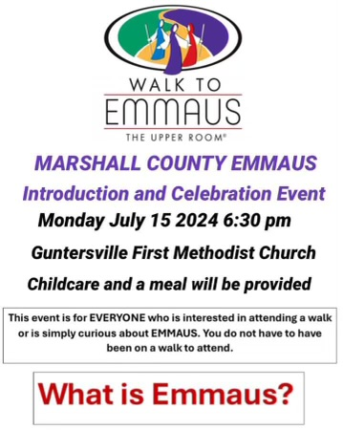

**Governing board meeting July 16th at 6:30 PM.**

**Family Potluck meal on July 17th at 6:00 PM. Bible study will follow the meal.**

**Men’s Breakfast on July 28th at 7:30 AM. One of the members of our church will give their testimony.**

**Upper Rooms in the Narthex for November and December.**

**Bible Study Sunday Mornings at 8:30 AM in choir room, facilitator Rod Eddleman.**

**Prayer Shawl Ministry, would you like to be part of this ministry contact Naomi**

**Herbert. This ministry will meet the 1st Monday of each month at 9 AM. Do you know someone that needs a 'Prayer Shawl'? Please provide that information (Name &Address)to one of the following: Naomi Herbert, Babs Holcomb, Glenda Mayo, Lisa Saylor, Kayla Cherry, or Carol Godsey.**

**Men's Spiritual Outreach for Addiction Recovery (SOFAR) at Cedar Lodge in**

**Claysville one Saturday per quarter – See Joey Croft for more information for men's**

**team ministry.**

**Women's SOFAR: Meet every Sat morning March & August for 2 hours. See Babs Holcomb or Cindy Kennamer for more info.**