**Order of Worship - New Life Methodist Church**

[**https://newlifemethodistchurch.org**](https://newlifemethodistchurch.org)

**Worship for Sunday, March 24th,2024**

**Parking Lot Greeter: Stan Emmons**

**Narthex Greeter: Robert & Mandy Patterson**

**Visitor Greeter: Kathy Giles**

**Projection Technician: Debbie Barr**

**Nursery for Service: Erica McCullogh**

**Worship Order**

**\*\*\*Children Singing & Waving Palm Branches\*\*\*\*\***

**Gathering Music starts at 9:20 am**

**Acolytes Bella Russell & Macie Patterson**

**Song Famous One**

**Song Glory to the King**

**Song Amazing Love**

**Welcome/Announcements/Joys &** **Joey Croft**

**Concerns/Prayer/Lord’s Prayer**

**Child Chat with** **Lana Bruno**

**Children Dismissed**

**Children’s Church Children Lesson** **“Hosanna in the Highest”**

**Children’s Church with Madison Carnes & Lana Bruno**

**Offertory Prayer Joey Croft**

**Offering Stan Emmons & Robert Patterson**

**Offertory Song** **Prepare the Way**

**Message by Joey Croft**

**Title “The King and I ”**

**Scripture Mark 11: 1-11**

**Song Unto the King**

**Acolytes Bella Russell & Macie Patterson**

**Locking Doors Billy Lewis**

**Announcements**

**Maundy Thursday Communion Service on Thursday March 28th at 6 PM**

**New Life Easter Party** **will be March 30th from 1:00-3:00 PM for children 3 - 11 years old. There will be food, fun, and easter eggs. Volunteers are needed. Please see Lana Bruno if you plan to volunteer.**

**Easter Sonrise Service will be March 31st starting at 6:15 AM .**

**Easter Morning breakfast after the Sonrise Service**

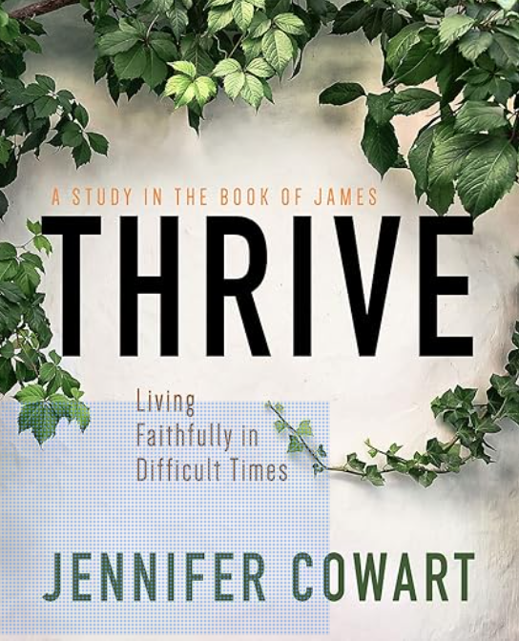

**Women's Bible Study**

**Wednesday Nights**

**Starting April 10th at 6:30pm**

**New Life Youth Center**

**Thrive: Living Faithfully in Difficult Times by Jennifer Cowart**

**Books may be ordered from Amazon. Sign-up with Milanda Taylor 256-656-0206.**

**Monthly Potluck Meal and Bible Study will be on April 17th at 6:00 PM**

**Upper Rooms in the Narthex for March & April**

**Bible Study Sunday Mornings at 8:30 AM in choir room, facilitator Rod Eddleman.**

**Prayer Shawl Ministry, would you like to be part of this ministry contact Naomi**

**Herbert. This ministry will meet the 1st Monday of each month at 9 AM. Do you know someone that needs a 'Prayer Shawl'? Please provide that information (Name &Address) to one of the following: Naomi Herbert, Babs Holcomb, Glenda Mayo, Lisa Saylor, Kayla Cherry, or Carol Godsey.**

**Men's Spiritual Outreach for Addiction Recovery (SOFAR) at Cedar Lodge in**

**Claysville one Saturday per quarter – See Joey Croft for more information for men's team ministry.**

**Women's SOFAR: Meet every Sat morning March & August for 2 hours. See Babs Holcomb or Cindy Kennamer for more info.**