**Order of Worship**

**New Life Methodist Church**

[**https://newlifemethodistchurch.org**](https://newlifemethodistchurch.org)

**Worship for Thursday, March 28th, 2024**

Welcome Milanda & Jim

Song **Blood on my Hands**

Song **Thief**

**Message Joey**

**Title** **“The Towel”**

**Scripture** John 13:1-17

Communion Joey & Milanda to serve communion

Prayer

**\*Congregation leaves in silence\***

**Announcements**

Maundy Thursday Communion Service on Thursday March 28th at 6 PM

New Life Easter Party will be March 30th from 1:00-3:00 PM for children 3 - 11 years old. There will be food, fun, and easter eggs. Volunteers are needed. Please see Lana Bruno if you plan to volunteer.

Easter Sonrise Service will be March 31st starting at 6:15 AM .

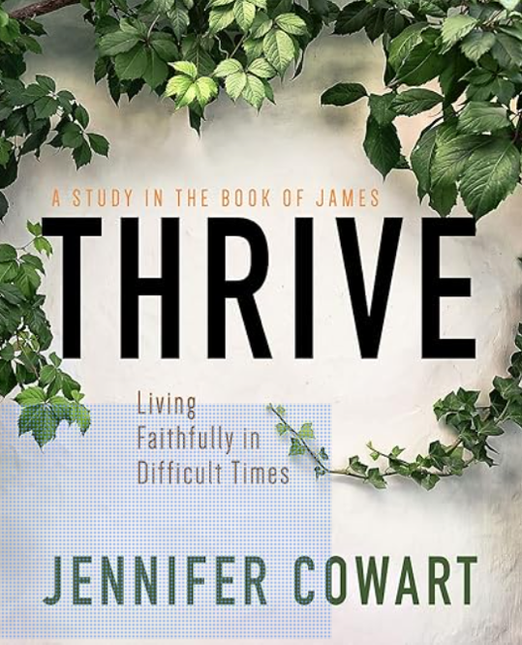Easter Morning breakfast after the Sonrise Service

Women's Bible Study   
Wednesday Nights  
Starting April 10th at 6:30pm  
New Life Youth Center  
Thrive: Living Faithfully in Difficult Times by Jennifer Cowart  
Books may be ordered from Amazon. Sign-up with Milanda Taylor 256-656-0206.

Monthly Potluck Meal and Bible Study will be on April 17th at 6:00 PM

Upper Rooms in the Narthex for March & April

Bible Study Sunday Mornings at 8:30 AM in choir room, facilitator Rod Eddleman.

Prayer Shawl Ministry, would you like to be part of this ministry contact Naomi

Herbert. This ministry will meet the 1st Monday of each month at 9 AM. Do you know someone that needs a 'Prayer Shawl'? Please provide that information (Name &Address) to one of the following: Naomi Herbert, Babs Holcomb, Glenda Mayo, Lisa Saylor, Kayla Cherry, or Carol Godsey.

Men's Spiritual Outreach for Addiction Recovery (SOFAR) at Cedar Lodge in

Claysville one Saturday per quarter – See Joey Croft for more information for men's team ministry.